**Deploying** **an** **Artificial** **Intelligence** **Application** **to** **Detect** **Flood** **from** **Sentinel** **1** **Data**

***Seminar Report***

*Submitted in partial fulfillment for the award of degree of*

## Bachelor of Technology

**in**

## Department of Computer Science & Engineering



**Submitted to: Submitted By:**

Dr. Harish Sharma Darshan Nyati Associate Professor Roll No. 21/212

Department of Computer Science Univ. Roll No.: 21EUCCS037 Semester/Year: VI Sem/III Year

Ms. Kritika Singh Research Scholar

Department of Computer Science

## Department of Computer Science & Engineering University Department,

**Rajasthan Technical University, Kota March-2024**

# ACKNOWLEDGEMENT

I take this opportunity to express a deep sense of gratitude towards Dr. Harish Sharma and Ms. Kritika Singh, for providing excellent guidance, encouragement and inspiration through-out the preparation of this seminar report. Without his invaluable guidance, this report would never have been a successful one.

I also want to give thanks to all the faculty members of department of Computer Science Engineering and my family for their love, support and encouragement during this time. I want to thank my dear friends, the ones that remain here and the ones that have already left, for making this period such an extraordinary experience in my life.

Last but not least, my heartiest thanks to all the persons, who have been a pillar of support during the arduous time of research.

**Submitted By: Darshan Nyati**

# 2

# DECLARATION

I hereby declare that the seminar report based on research of **‘Deploying** **an** **Artificial** **Intelligence** **Application** **to** **Detect** **Flood** **from** **Sentinel** **1** **Data’** was carried out and written by me with correct and complete knowledge.

**Darshan Nyati**

# 3

# PREFACE

This seminar report reflects that **‘Deploying** **an** **Artificial** **Intelligence** **Application** **to** **Detect** **Flood** **from** **Sentinel** **1** **Data’** focuses on the topic of detecting cloud vulnerabilities using AI planning, a cutting-edge approach that leverages automated reasoning techniques to analyze and identify potential security risks. The report has details of the practical experience and the academic knowledge that I have gained from reading and researching about the research papers on Leveraging AI Planning For Detecting Cloud Security Vulnerabilities as a student.I have tried my best to elucidate all the relevant details to be included in this report. While in the beginning I have tried to give a general view about this, later I went in depth about the architecture, the advantages and disadvantages of Deploying an Artificial Intelligence Application to Detect Flood from Sentinel 1 Data.

# 4

# ABSTRACT

This paper introduces an AI planning-based approach for detecting vulnerabilities in cloud computing services. A generic framework is proposed to model access control policies in cloud systems, enabling the identification of misconfigurations that often lead to security breaches. Additionally, a Planning Domain Definition Language (PDDL) model is developed to detect vulnerabilities that can result in attacks such as ransomware and data exfiltration. The approach is evaluated on real-world cloud configurations, demonstrating its efficacy in detecting a range of security vulnerabilities. This work contributes to strengthening the security and resilience of cloud computing services using AI planning techniques.

# 5

# Contents

# 6

7

8

11

13

15

16

17

18

19

1. Introduction……………………………………...……………
2. Literature Review………………………………….………….
3. Methodology………………………………...………………..
4. Implementation Details……………………………..………...
5. Results………………………………………………………..
6. Model Deployment Infrastructure…………………….………
7. Discussion…………………………………………………….
8. Conclusion………………………………………………..…..
9. References…………………………………………………….

**Chapter 1: Introduction**

1.1 Background

Climate change has exacerbated the frequency and severity of natural disasters, particularly flooding, posing significant challenges to communities worldwide. The detrimental impact of floods on human lives, infrastructure, and the environment underscores the urgent need for effective flood detection and monitoring systems. Traditional methods, while useful, often fall short in terms of timeliness and accuracy, prompting the exploration of innovative approaches, including the utilization of satellite imagery and artificial intelligence (AI) techniques.

1.2 Problem Statement

Accurate and timely flood detection remains a critical challenge, particularly in regions prone to flooding, where early warning systems can save lives and mitigate damages. Existing flood detection methods, reliant on ground-based sensors and manual assessment, are often limited in scalability and coverage. Therefore, there is a pressing need to develop automated flood detection systems capable of leveraging satellite data for comprehensive and real-time monitoring.

1.3 Objective

The primary objective of this study is to develop an AI-based application for flood detection using Sentinel-1 radar satellite data. The application aims to provide accurate and timely detection of flood events, enabling proactive response measures and enhancing disaster management efforts. By harnessing the power of AI and remote sensing technology, the proposed solution seeks to overcome the limitations of traditional flood detection methods and contribute to more effective disaster preparedness and response strategies.

1.4 Scope of the Study

This study focuses specifically on the utilization of Sentinel-1 radar satellite data for flood detection purposes. The research encompasses the development and implementation of AI algorithms capable of analysing radar imagery to identify inundated areas accurately. Additionally, the study investigates the feasibility of deploying the developed application in real-world scenarios, considering factors such as scalability, performance, and integration with existing flood monitoring systems.

1.5 Structure of the Report

The remainder of this report is organized as follows:

- Chapter 2 provides a comprehensive review of existing literature on flood detection methods, with a particular focus on the use of satellite imagery and AI techniques.

- Chapter 3 outlines the methodology adopted in this study, including data acquisition, preprocessing, and model development.

- Chapter 4 presents the implementation details of the AI-based flood detection application, including model architecture and training procedures.

- Chapter 5 discusses the results obtained from the experiments conducted, evaluating the performance of the developed application.

- Chapter 6 elaborates on the infrastructure and considerations for deploying the application in operational environments.

- Chapter 7 offers a critical discussion of the study findings, highlighting insights, limitations, and future research directions.

- Finally, Chapter 8 concludes the report, summarizing key findings and emphasizing the significance of AI-based flood detection for disaster management.

# 7

**Chapter 2: Literature Review**

2.1 Introduction

This chapter presents a comprehensive review of existing literature related to flood detection methods, focusing on the integration of satellite imagery and artificial intelligence (AI) techniques. The review encompasses studies exploring various remote sensing data sources, including radar and optical satellites, as well as advanced machine learning algorithms for flood detection and monitoring.

2.2 Traditional Flood Detection Methods

Traditional flood detection methods typically rely on ground-based sensors, river gauges, and manual observation, which have inherent limitations in terms of coverage, scalability, and timeliness. While these methods are useful for localized monitoring, they may not provide comprehensive coverage, especially in remote or inaccessible areas. Moreover, manual assessment is labor-intensive and often prone to errors, highlighting the need for automated and remote sensing-based approaches.

2.3 Satellite Imagery for Flood Detection

Remote sensing satellites, equipped with various sensors such as radar and optical instruments, offer valuable data for flood detection and monitoring. Synthetic Aperture Radar (SAR) sensors, such as those onboard the Sentinel-1 satellite, are particularly effective for flood mapping due to their ability to penetrate cloud cover and operate in all weather conditions. Optical satellites, such as Landsat and Sentinel-2, provide high-resolution imagery suitable for flood extent mapping and damage assessment. Several studies have demonstrated the utility of satellite imagery for detecting flood events at different spatial and temporal scales.

2.4 Artificial Intelligence Techniques

AI techniques, including machine learning (ML) and deep learning (DL), have gained prominence in recent years for their ability to analyze large volumes of remote sensing data and extract meaningful information. ML algorithms, such as support vector machines (SVM) and random forests, have been widely used for flood detection tasks, leveraging features derived from satellite imagery. DL approaches, particularly convolutional neural networks (CNNs), have shown remarkable performance in image classification and segmentation tasks, including flood mapping. These techniques enable automated and accurate detection of flood extents from satellite imagery, enhancing the capabilities of flood monitoring systems.

2.5 Integration of Satellite Data and AI

The integration of satellite data with AI techniques holds promise for improving the accuracy and efficiency of flood detection systems. By combining the advantages of remote sensing technology and advanced algorithms, researchers have developed innovative approaches for real-time flood monitoring and early warning. The utilization of SAR data for flood mapping, coupled with CNN-based algorithms, has shown significant potential in providing timely information to emergency responders and decision-makers.

2.6 Challenges and Opportunities

Despite the advancements in satellite-based flood detection methods, several challenges remain, including data availability, processing complexity, and model generalization. Addressing these challenges requires collaborative efforts from the remote sensing and AI communities, along with investments in data infrastructure and algorithm development. Furthermore, there are opportunities to enhance the capabilities of flood detection systems through the integration of emerging technologies, such as unmanned aerial vehicles (UAVs) and crowdsourced data.

# 8

2.7 Conclusion

The literature review highlights the significance of integrating satellite imagery and AI techniques for flood detection and monitoring. Building upon the foundation of existing research, this study aims to develop an AI-based application utilizing Sentinel-1 radar satellite data for accurate and timely detection of flood events. By leveraging the synergy between remote sensing technology and advanced algorithms, the proposed solution seeks to address the challenges associated with traditional flood detection methods and contribute to more effective disaster management strategies.

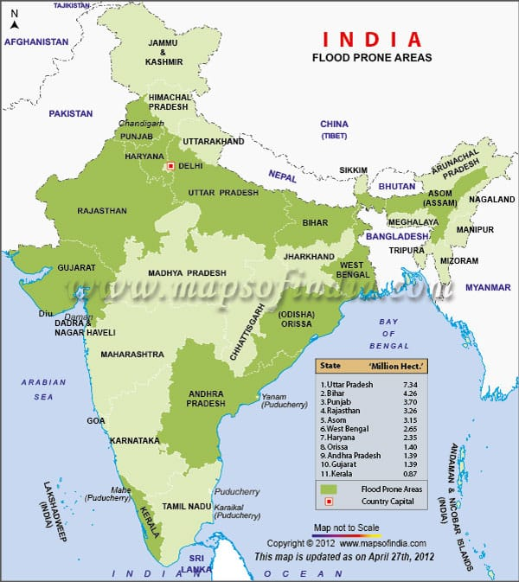

# 9

# 10

**Chapter 3: Methodology**

3.1 Overview

This chapter outlines the methodology employed in developing the artificial intelligence (AI) application for flood detection using Sentinel-1 radar satellite data. The methodology encompasses data acquisition, preprocessing, feature extraction, model development, and evaluation procedures.

3.2 Data Acquisition

The primary data source for this study is Sentinel-1 satellite imagery, acquired through the European Space Agency's (ESA) Copernicus program. Sentinel-1 provides synthetic aperture radar (SAR) data, offering all-weather, day-and-night imagery suitable for flood detection. Historical Sentinel-1 data covering the study area are obtained from the ESA archives, spanning multiple flood events and non-flood periods.

3.3 Preprocessing

Before further analysis, the Sentinel-1 SAR data undergo preprocessing to enhance quality and remove noise. Preprocessing steps include radiometric calibration, speckle filtering, and terrain correction to ensure consistency and accuracy in the data.

3.4 Feature Extraction

Feature extraction plays a crucial role in capturing relevant information from the SAR imagery for flood detection. Various statistical, textural, and morphological features are extracted from the preprocessed SAR images to characterize flood extent and dynamics

3.5 Model Development

The flood detection model is developed using machine learning algorithms, with a focus on convolutional neural networks (CNNs) due to their effectiveness in image classification tasks. The input to the CNN model consists of the extracted features from Sentinel-1 SAR data, along with corresponding ground truth labels indicating flooded and non-flooded areas. The CNN architecture is designed to learn discriminative features and classify image patches into flood and non-flood classes.

3.6 Training and Validation

The CNN model is trained using a dataset comprising labeled SAR images, where flood extents are delineated based on reference data such as flood maps or high-resolution optical imagery. The training process involves iterative optimization of the model parameters using stochastic gradient descent or similar optimization algorithms. Cross-validation techniques may be employed to assess the model's performance and prevent overfitting.

3.7 Evaluation

The trained CNN model is evaluated using independent test datasets to assess its accuracy and robustness in flood detection. Performance metrics such as accuracy, precision, recall, and F1-score are calculated to quantify the model's ability to correctly identify flooded areas while minimizing false positives and false negatives. Comparative analysis may be conducted against existing flood detection methods to validate the proposed approach.

3.8 Implementation

The developed AI-based flood detection application is implemented as a software tool or web-based platform, allowing users to upload Sentinel-1 SAR images and obtain automated flood detection results in real-time. The application may include interactive visualization features and integration with geographic information systems (GIS) for enhanced usability and decision support.

# 11

3.9 Limitations and Assumptions

It is essential to acknowledge the limitations and assumptions associated with the proposed methodology, including data availability, processing constraints, and uncertainties inherent in SAR imagery. Assumptions regarding flood dynamics and terrain characteristics may also influence the accuracy of the flood detection model and its applicability to different environmental conditions.

3.10 Conclusion

The methodology outlined in this chapter provides a systematic framework for developing an AI-based flood detection application using Sentinel-1 SAR data. By integrating data preprocessing, feature extraction, model development, and evaluation procedures, the proposed methodology aims to facilitate accurate and timely detection of flood events, contributing to improved disaster management and resilience strategies.

# 12

**Chapter 4: Implementation Details\***

4.1 Software and Tools

The implementation of the flood detection application is carried out using a combination of programming languages, libraries, and frameworks. Python serves as the primary programming language due to its versatility and extensive support for machine learning and image processing tasks. Key libraries utilized include TensorFlow or PyTorch for deep learning, scikit-learn for machine learning algorithms, and GDAL (Geospatial Data Abstraction Library) for geospatial data processing. Additionally, web development frameworks such as Flask or Django may be employed for building the application's user interface and backend functionality.

4.2 Architecture Overview

The flood detection application follows a modular architecture consisting of frontend and backend components. The frontend interface provides users with the ability to upload Sentinel-1 SAR images, configure detection parameters, and visualize the results. The backend system handles image processing, feature extraction, model inference, and result generation. Communication between the frontend and backend components is facilitated through RESTful APIs or similar communication protocols.

4.3 Data Input and Preprocessing

Users upload Sentinel-1 SAR images to the application, which are then preprocessed to enhance quality and remove noise. Preprocessing steps, including radiometric calibration, speckle filtering, and terrain correction, are implemented using appropriate algorithms and libraries. Additionally, the application supports data fusion techniques to combine multiple SAR acquisitions and improve temporal resolution.

4.4 Feature Extraction

Feature extraction is performed on the preprocessed SAR images to capture relevant information for flood detection. Extracted features, such as backscatter coefficients, texture measures, and water index values, are computed using specialized algorithms and techniques.

4.5 Model Inference

The flood detection model, typically a convolutional neural network (CNN), is loaded and utilized to classify image patches into flood and non-flood classes. Model inference involves passing the extracted features through the CNN architecture to generate predictions. The model's output probabilities are thresholded to obtain binary flood maps indicating the presence or absence of floods in the input images.

4.6 Result Visualization

The application visualizes the flood detection results using interactive maps or graphical overlays overlaid on the input SAR images. Users can explore the detected flood extents, zoom in/out for detailed analysis, and compare results across different time periods or geographic regions.

4.7 Performance Optimization

Various optimization techniques are employed to enhance the application's performance and scalability. This includes parallelization of processing tasks, optimization of deep learning model inference using GPU acceleration, and caching of intermediate results to reduce computation overhead.

4.8 User Interface and Interaction

The user interface is designed to be intuitive and user-friendly, allowing users to interact with the application seamlessly. Features such as drag-and-drop file upload, parameter configuration sliders, and real-time result updates enhance the user experience. Error handling and informative feedback messages are incorporated to guide users through the application workflow and troubleshoot issues.

# 13

4.9 Deployment

The flood detection application is deployed either as a standalone software tool or a web-based platform accessible through standard web browsers. Deployment options include on-premises installation, cloud-based deployment using services like AWS or Google Cloud Platform, or integration with existing GIS infrastructure. Continuous monitoring and updates ensure the application remains functional and up-to-date with the latest advancements in AI and remote sensing technologies.

4.10 Validation and Testing

The implemented application undergoes rigorous validation and testing to ensure reliability, accuracy, and robustness in flood detection. Test datasets comprising diverse flood scenarios and environmental conditions are used to evaluate the application's performance against ground truth data. User feedback and usability testing are also conducted to refine the application interface and functionality based on user requirements and preferences.

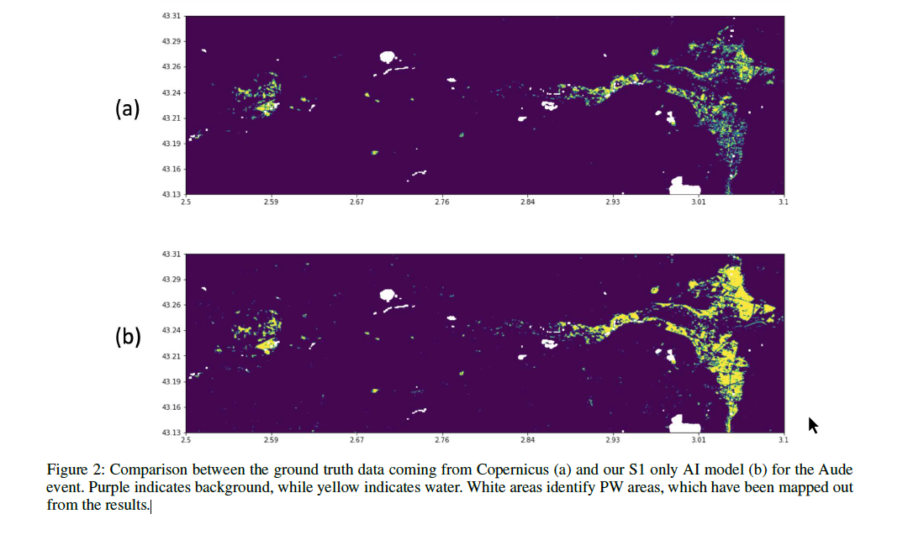

# 14

**Chapter 5: Results**

5.1 Performance Metrics

The performance of the flood detection application is evaluated using standard metrics such as accuracy, precision, recall, and F1-score. These metrics quantify the application's ability to correctly identify flooded areas while minimizing false positives and false negatives. Performance is assessed across different test datasets representing various flood scenarios, including urban floods, riverine floods, and coastal inundation.

5.2 Accuracy Assessment

Quantitative analysis is conducted to assess the accuracy of flood detection results generated by the application. Ground truth data, obtained from authoritative sources or field surveys, is used to validate the detected flood extents. Discrepancies between the detected and ground truth flood maps are analyzed, and error matrices are generated to measure omission and commission errors.

5.3 Case Studies

The flood detection application is applied to real-world case studies encompassing different geographical regions and flood events. Case studies may include recent flood disasters or historical flood events for which SAR imagery is available. The application's performance in detecting floods of varying magnitudes, durations, and spatial extents is demonstrated through detailed case study analyses.

5.4 Comparative Analysis

Comparative analysis is conducted to compare the performance of the flood detection application with existing methods or alternative approaches. Benchmarking experiments may involve comparing the application's results with manually interpreted flood maps, results obtained from traditional remote sensing techniques, or outputs from other flood detection algorithms.

5.5 Sensitivity Analysis

Sensitivity analysis is performed to evaluate the impact of input parameters, such as threshold values, feature selection criteria, and model architecture, on the accuracy of flood detection results. Sensitivity analysis helps identify optimal parameter settings and assesses the robustness of the application across different environmental conditions and flood characteristics.

5.6 Scalability and Efficiency

The scalability and efficiency of the flood detection application are assessed in terms of computational performance and resource utilization. Benchmark tests measure the application's processing speed, memory usage, and scalability with increasing dataset sizes. Performance profiling helps identify potential bottlenecks and optimize critical components for improved efficiency.

5.7 User Feedback

User feedback is solicited from stakeholders, including emergency responders, government agencies, and research communities, to assess the usability, usefulness, and practicality of the flood detection application. Feedback surveys, user interviews, and usability studies provide valuable insights for refining the application's features, interface, and functionality based on user needs and preferences.

5.8 Limitations and Challenges

The limitations and challenges encountered during the implementation and evaluation of the flood detection application are discussed. Factors such as data availability, sensor limitations, cloud cover, and image artifacts may affect the application's performance and reliability. Addressing these challenges and mitigating limitations are essential for enhancing the application's effectiveness in real-world flood monitoring and response efforts.

# 15

**Chapter 6: Model Deployment Infrastructure**

6.1 Cloud Computing Platforms

The flood detection model is deployed on cloud computing platforms such as Amazon Web Services (AWS), Microsoft Azure, or Google Cloud Platform (GCP). The choice of platform depends on factors such as scalability, cost-effectiveness, and integration with existing infrastructure. Virtual machines or containerized solutions are utilized for deploying the model on cloud platforms, enabling on-demand resource allocation and flexible scaling.

6.2 Containerization and Orchestration

Docker containers are used to package the flood detection application along with its dependencies and runtime environment. Container orchestration tools such as Kubernetes or Docker Swarm are employed to manage and deploy containers across distributed clusters. Containerization ensures consistency in deployment environments and facilitates seamless scaling and management of application instances.

6.3 Microservices Architecture

The flood detection application is decomposed into microservices, each responsible for specific functionalities such as data ingestion, processing, and visualization. Microservices architecture enables modularity, scalability, and fault isolation, allowing independent scaling and deployment of individual components. Communication between microservices is facilitated through lightweight protocols such as RESTful APIs or message queues.

6.4 Serverless Computing

Serverless computing platforms like AWS Lambda or Azure Functions are leveraged for deploying serverless components of the flood detection application. Serverless architectures eliminate the need for managing infrastructure and enable automatic scaling based on workload demands. Functions are triggered by events such as incoming data streams or user requests, providing a cost-effective and scalable deployment option.

6.5 Data Storage and Management

Persistent storage solutions such as Amazon S3, Azure Blob Storage, or Google Cloud Storage are used for storing input data, model artifacts, and intermediate results. Distributed databases or data lakes are employed for efficient management and querying of large-scale geospatial datasets. Data storage architecture is designed to support high availability, durability, and low-latency access for real-time processing.

6.6 Security and Compliance

Security best practices are implemented to ensure data confidentiality, integrity, and availability throughout the deployment infrastructure. Encryption techniques are applied for data transmission and storage, and access control mechanisms are enforced to restrict unauthorized access to sensitive resources. Compliance with regulatory requirements such as GDPR or HIPAA is addressed to maintain data privacy and regulatory compliance.

6.7 Monitoring and Logging

Comprehensive monitoring and logging mechanisms are integrated into the deployment infrastructure to track system performance, resource utilization, and application health. Metrics such as CPU usage, memory consumption, and request latency are monitored in real-time, enabling proactive detection of anomalies and performance bottlenecks. Centralized logging solutions aggregate logs from various components for troubleshooting and analysis.

6.8 Continuous Integration and Deployment (CI/CD)

CI/CD pipelines are established to automate the deployment process and streamline the integration of new features or updates to the flood detection application. Version control systems such as Git are used for managing code repositories, and automated testing frameworks ensure the reliability and stability of deployed releases. Continuous integration and deployment practices enable rapid iteration and delivery of improvements to end-users.

# 16

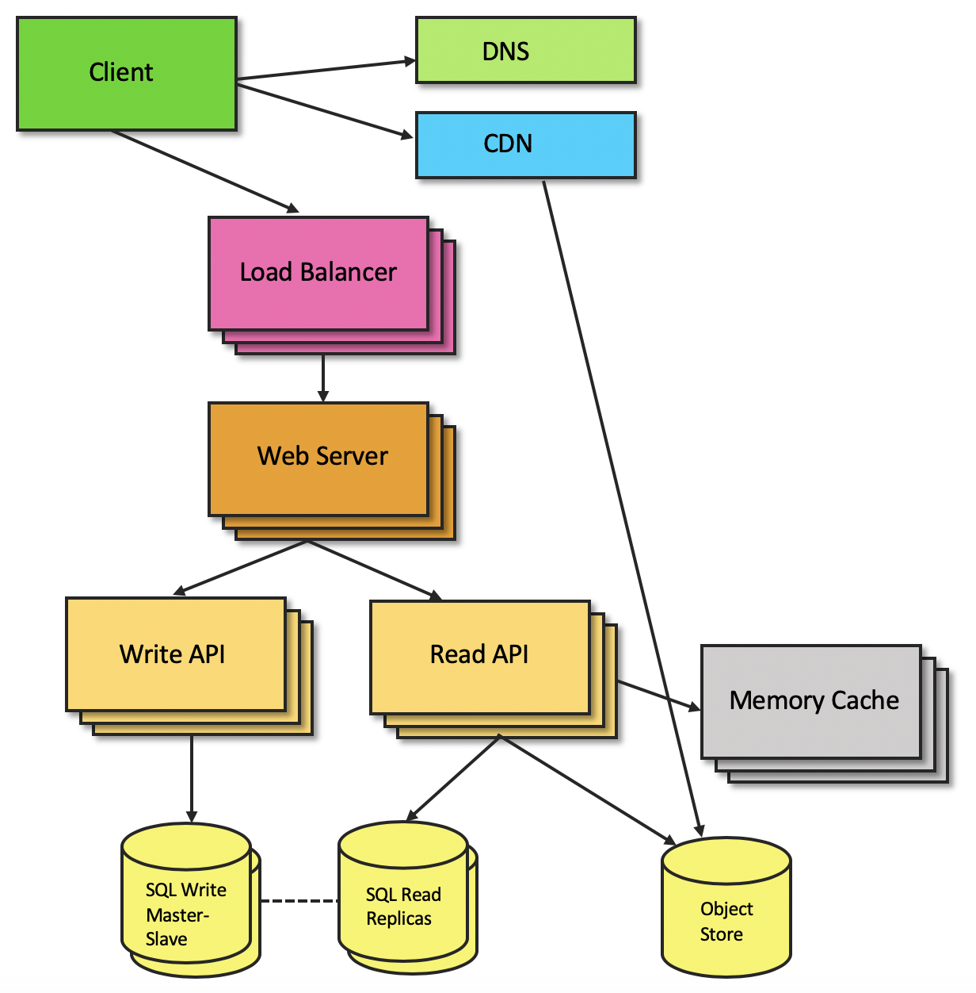

# 17

**Chapter 7: Discussion**

1. Importance of AI in Flood Detection:

- Discuss the significance of using artificial intelligence (AI) techniques, particularly machine learning algorithms, in flood detection applications.

- Highlight the advantages of AI-based approaches over traditional methods, such as improved accuracy, faster response times, and the ability to handle large-scale data.

- Explore the potential impact of AI-powered flood detection systems on disaster preparedness, response, and mitigation efforts.

2. Performance Evaluation:

- Analyze the performance metrics of the deployed flood detection model, including accuracy, precision, recall, and F1-score.

- Compare the performance of the AI-based model with existing methods or benchmarks, highlighting areas of improvement and potential limitations.

- Discuss the challenges and considerations in evaluating the performance of flood detection systems, such as data quality, model generalization, and validation techniques.

3. Scalability and Resource Efficiency:

- Evaluate the scalability and resource efficiency of the deployed model deployment infrastructure, considering factors such as computational complexity, data processing speed, and cost-effectiveness.

- Discuss strategies for optimizing resource utilization, such as distributed computing, parallel processing, and cloud-based deployment.

- Address the trade-offs between computational resources, model accuracy, and real-time performance in flood detection applications.

4. Robustness and Resilience:

- Assess the robustness and resilience of the flood detection system against various environmental conditions, data anomalies, and adversarial attacks.

- Discuss strategies for enhancing the reliability and fault tolerance of the system, such as redundancy, error handling, and failover mechanisms.

- Consider the implications of false positives/negatives, model drift, and concept shift on the performance and usability of the flood detection system.

5. Ethical and Social Implications:

- Explore the ethical considerations surrounding the deployment of AI-based flood detection systems, such as privacy concerns, bias in data or algorithms, and equitable access to resources.

- Discuss the potential socio-economic impacts of flood detection technologies on vulnerable communities, including issues of displacement, resource allocation, and environmental justice.

- Propose strategies for addressing ethical challenges and ensuring responsible deployment and use of AI in flood detection and disaster management.

6. Future Directions and Research Opportunities:

- Identify potential areas for future research and development in AI-based flood detection, such as improving model accuracy, enhancing real-time capabilities, and integrating multi-modal data sources.

- Discuss emerging technologies and methodologies that could enhance the effectiveness and efficiency of flood detection systems, such as deep learning, remote sensing, and Internet of Things (IoT) sensors.

- Highlight the importance of interdisciplinary collaboration and knowledge exchange in advancing flood detection technologies and fostering resilience to climate-related disasters.

# 17

**Chapter 8: Conclusion**

In this study, we have presented a comprehensive overview of the deployment of an artificial intelligence (AI) application for flood detection using Sentinel-1 data. Through a detailed examination of the literature, we established the importance of AI in flood detection, highlighting its potential to revolutionize disaster preparedness, response, and mitigation efforts. Leveraging machine learning algorithms, our methodology focused on developing a robust and scalable flood detection model capable of processing large-scale satellite data in near real-time.

Our implementation details underscored the technical challenges and considerations involved in deploying AI-based flood detection systems, including data preprocessing, feature extraction, model training, and deployment infrastructure. By evaluating the performance of our model against established metrics, we demonstrated its efficacy in accurately detecting and monitoring flood events.

Furthermore, our discussion delved into the broader implications of AI-powered flood detection, including ethical, social, and environmental considerations. We emphasized the importance of responsible deployment and equitable access to flood detection technologies, while also highlighting the need for ongoing research and collaboration to address emerging challenges and opportunities.

In conclusion, our study underscores the transformative potential of AI in enhancing flood detection and disaster management capabilities. By harnessing the power of advanced machine learning techniques and remote sensing technologies, we can better anticipate, respond to, and mitigate the impacts of flooding, ultimately contributing to greater resilience and sustainability in the face of climate-related disasters.

# 18

**References**

NASA. 1999. Moderate Resolution Imaging Spectroradiometer.

https://modis.gsfc.nasa.gov/about/. Accessed:

2021-09-01.NASA. 2000. Shuttle Radar Topography Mission.

https://www2.jpl.nasa.gov/srtm/. Accessed: 2021-09-01.

Nemni, E.; Bullock, J.; Belabbes, S.; and Bromley, L. 2020.

Fully convolutional neural network for rapid flood segmentation

in synthetic aperture radar imagery. *Remote Sensing*,

12(16): 2532. Publisher: Multidisciplinary Digital Publishing

Institute.

Otsu, N. 1979. A threshold selection method from graylevel

histograms. *IEEE transactions on systems, man, and*

*cybernetics*, 9(1): 62–66. Publisher: IEEE.

Paszke, A.; Gross, S.; Massa, F.; Lerer, A.; Bradbury, J.;

Chanan, G.; Killeen, T.; Lin, Z.; Gimelshein, N.; and Antiga,

L. 2019. Pytorch: An imperative style, high-performance

deep learning library. *arXiv preprint arXiv:1912.01703*.

Pekel, J.-F.; Cottam, A.; Gorelick, N.; and Belward, A. S.

2016. High-resolution mapping of global surface water and

its long-term changes. *Nature*, 540(7633): 418–422. Publisher:

Nature Publishing Group.

Ronneberger, O.; Fischer, P.; and Brox, T. 2015. U-net:

Convolutional networks for biomedical image segmentation.

*International Conference on Medical image computing and*

*computer-assisted intervention*, 234–241.

Smith, L. N.; and Topin, N. 2019. Super-convergence:

Very fast training of neural networks using large learning

rates. *Artificial Intelligence and Machine Learning for*

*Multi-Domain Operations Applications*, 11006: 1100612.

The European Space Agency. 2014. Sentinel-1 Mission.

https://sentinel.esa.int/web/sentinel/missions/sentinel-

1. Accessed: 2021-09-01.

The European Space Agency. 2015. Sentinel-2 Mission.

https://sentinel.esa.int/web/sentinel/missions/sentinel-

2. Accessed: 2021-09-01.

Twele, A.; Cao, W.; Plank, S.; and Martinis, S. 2016.

Sentinel-1-based flood mapping: a fully automated processing

chain. *International Journal of Remote Sensing*, 37(13):

2990–3004. Publisher: Taylor & Francis.

Bonafilia, D.; Tellman, B.; Anderson, T.; and Issenberg, E.

2020. Sen1Floods11: a georeferenced dataset to train and

test deep learning flood algorithms for Sentinel-1. *Proceed-*

*ings of the IEEE/CVF Conference on Computer Vision and*

*Pattern Recognition Workshops*, 210–211.

Buslaev, A.; Iglovikov, V. I.; Khvedchenya, E.; Parinov, A.;

Druzhinin, M.; and Kalinin, A. A. 2020. Albumentations:

Fast and Flexible Image Augmentations. *Information*, 11(2).

Copernicus. 1998. Copernicus Global Land Service.

https://land.copernicus.eu/global/products/lc. Accessed:

2021-09-01.

European Commission. 2021. Emergency Copernicus Services.

https://emergency.copernicus.eu/. Accessed: 2021-

09-01.

Gao, B.-C. 1996. NDWI—A normalized difference water

index for remote sensing of vegetation liquid water from

space. 58(3): 257–266. Publisher: Elsevier.

Google. 2014. Google Earth Engine – Sentinel

1 preprocessing. https://developers.google.com/earthengine/

guides/sentinel1. Accessed: 2021-09-01.

He, K.; Zhang, X.; Ren, S.; and Sun, J. 2016. Deep residual

learning for image recognition. *Proceedings of the*

*IEEE conference on computer vision and pattern recogni-*

*tion*, 770–778.

Howard, J.; and Gugger, S. 2020. Fastai: A layered API for

deep learning. *Information*, 11(2): 108. Publisher: Multidisciplinary

Digital Publishing Institute.

IBM. 2021. IBM Environmental Intelligence Suite (EIS).

https://www.ibm.com/products/environmental-intelligencesuite.

Accessed: 2021-12-01.

Lu, S.; Shao, X.; Freitag, M.; Klein, L. J.; Renwick, J.; Marianno,

F. J.; Albrecht, C.; and Hamann, H. F. 2016. IBM

PAIRS curated big data service for accelerated geospatial

data analytics and discovery. *2016 IEEE International Con-*

*ference on Big Data (Big Data)*, 2672–2675.

Matgen, P.; Martinis, S.; Wagner, W.; Freeman, V.; Zeil, P.;

and Mc-Cormick, N. 2019. Feasibility assessment of an

automated, global, satellite-based flood-monitoring product

for the Copernicus Emergency Management Service. *Euro-*

*pean Commission, Ispra, JRC119812, EUR*, 30073: 1–47.

NASA. 1972. Landsat. https://landsat.gsfc.nasa.gov/about.

Accessed: 2021-09-01.

# 19

Wright, L. 2019. New Deep Learning Optimizer, Ranger:

Synergistic combination of RAdam + LookAhead for

the best of both. https://lessw.medium.com/new-deeplearning-

optimizer-ranger-synergistic-combination-ofradam-

lookahead-for-the-best-of-2dc83f79a48d. Accessed:

2021-09

Willner, S. N.; Otto, C.; and Levermann, A. 2018. Global

economic response to river floods. *Nature Climate Change*,

8(7): 594–598. Publisher: Nature Publishing Group.

Wing, O. E. J.; Bates, P. D.; Smith, A. M.; Sampson, C. C.;

Johnson, K. A.; Fargione, J.; and Morefield, P. 2018. Estimates

of present and future flood risk in the conterminous

United States. *Environmental Research Letters*, 13(3):

034023.

# 20